**Jupyter Notebook in Amazon SageMaker Unified Studio**

**Objective**

Deploy and run a machine learning notebook (Iris_flower_classification.ipynb) using Amazon SageMaker Unified Studio—leveraging a custom SageMaker Domain .

**Step-by-Step Process**

**1. Creating a SageMaker Domain**

* In the AWS Console, navigated to **Amazon SageMaker** → **Domains**.
* Clicked **“Create domain”** and configured:
  + **Domain Name:** sagemaker-domain
* Completed domain creation

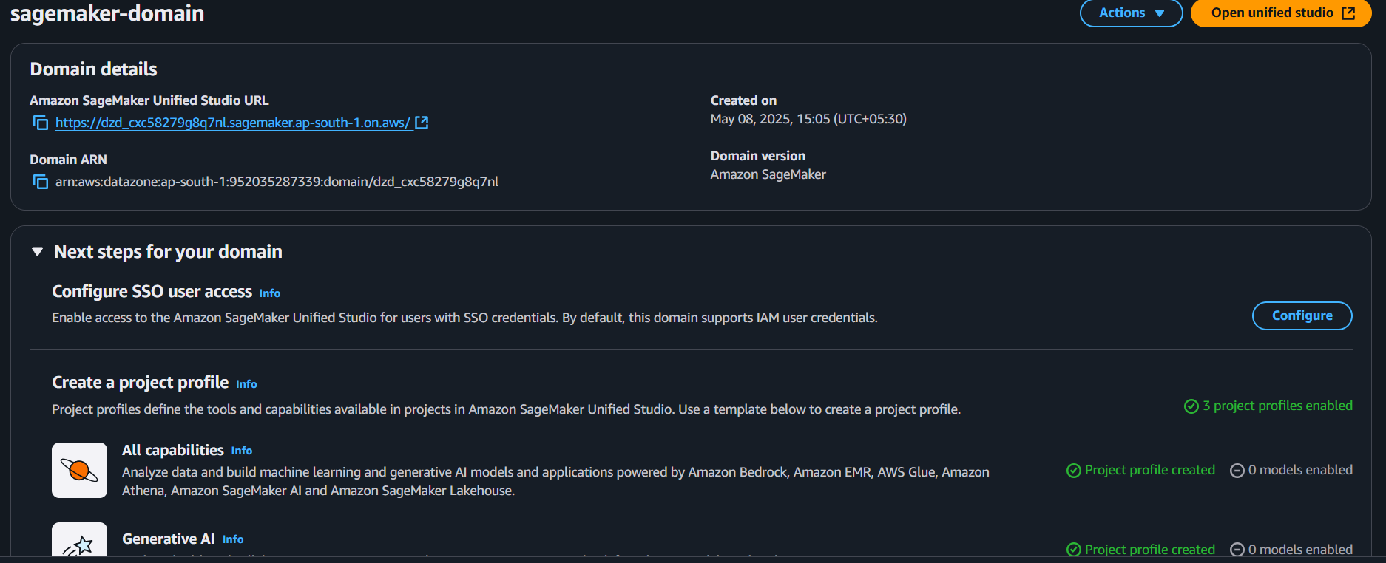

**2. Accessing Unified Studio via the Custom Domain**

* From the SageMaker console, selected the newly created **sagemaker-domain**.
* Clicked **“Open Studio”** to launch SageMaker Unified Studio under that domain.

**3. Creating a New Project in Unified Studio**

* On the Unified Studio landing page, clicked **“Create project”**.
* Entered project details:
  + **Project Name:** My_iris_project

**4. Launching the JupyterLab IDE**

* In the project’s overview page, selected **“Build”** → **“JupyterLab”**.
* SageMaker launched the JupyterLab environment tied to iris-classification-project.

**5. Uploading Notebook and Dataset**

* In JupyterLab’s File Browser pane, clicked the **Upload Files** button.
* Uploaded:
  + Iris_flower_classification.ipynb
  + iris_dataset.csv

**6. Configuring and Running the Notebook**

* Opened Iris_flower_classification.ipynb by double-clicking in the File Browser.
* Selected **Python 3 (Data Science)** kernel.

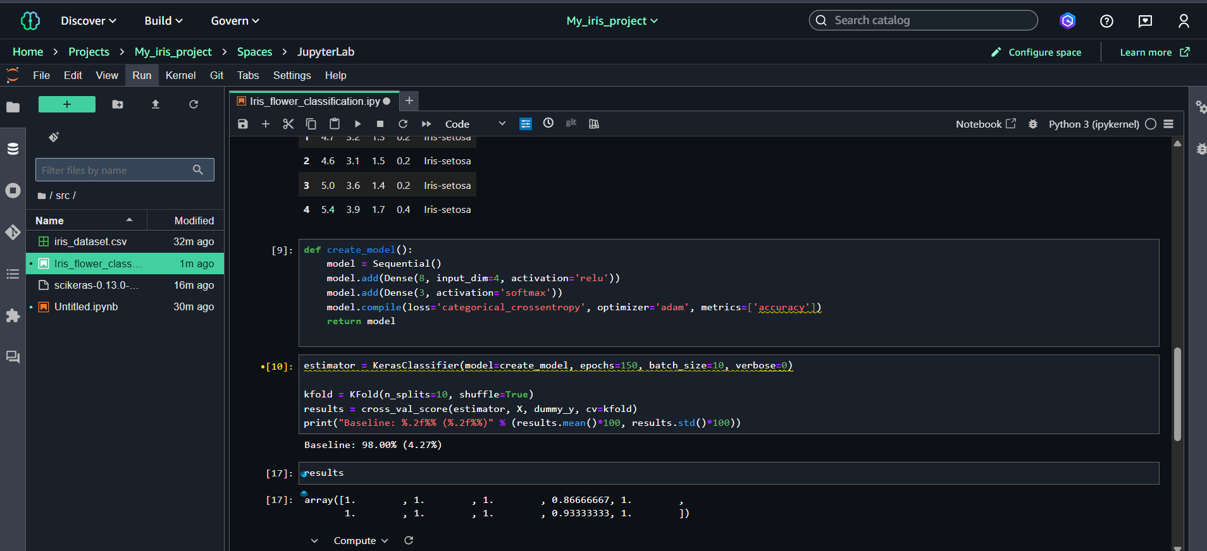

**Outcome**

Successfully ran the Iris classification notebook within a custom SageMaker Domain and Unified Studio project.